COLLEGE SYSTEM

Create database college_system:

C:\Users\Swetha\Desktop\Dbms\4.db8.PNG

Use database college_system:

C:\Users\Swetha\Desktop\Dbms\4.db1.PNG

Create table emp,dept,work:

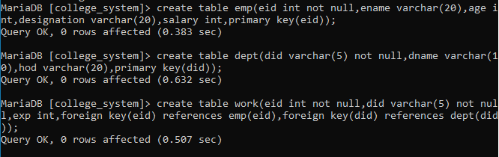

Insert datas into the table emp,dept,work:

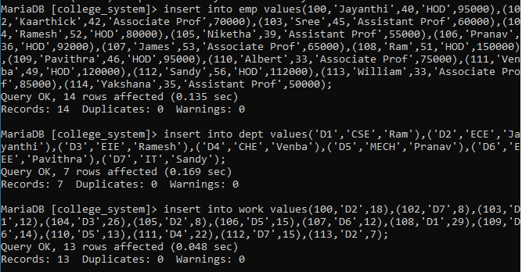

Display datas from the table emp:

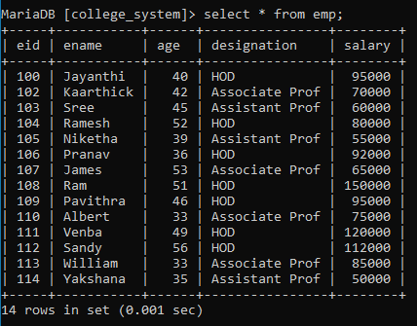

Display datas from the table dept:

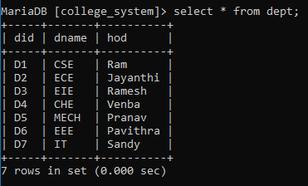

Display datas from the table work:

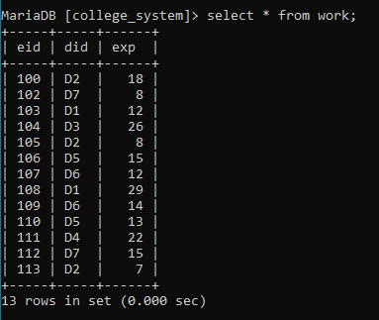

1. Display the details of employees who have more than 10 years of experience.

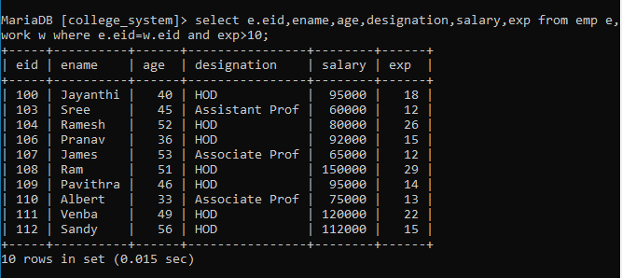

2.Display the names and salary of employee whose salary is greater than the average salary of the employees:

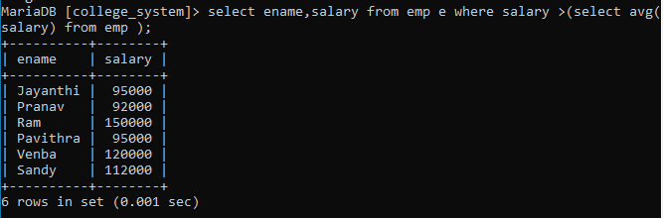

3.Display the names of employees whose age is less than 40,salary is greater than 50000 and work experience is greater than 10 years:

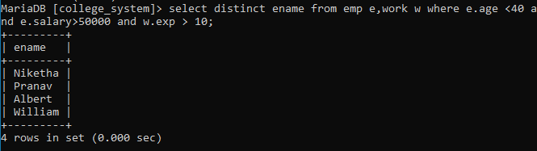

4.Display the count of employees in the department D2:

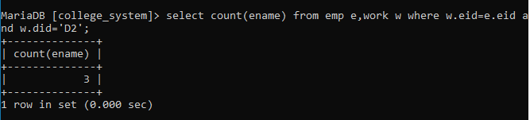

5.Display the employee name and their experience ordered by experience in descending order: .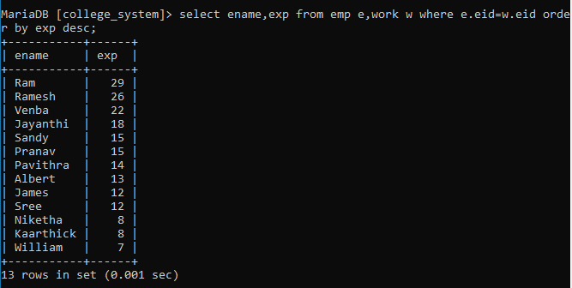

6.Display the employee name ,department id and their years of experience:

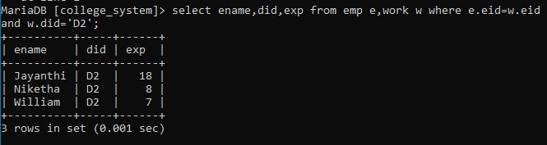

7.Display the department id and the count of the employees:

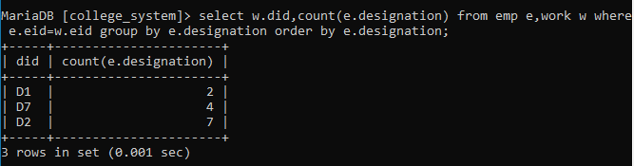

8. Display the name of the department which has more number of experienced employees.

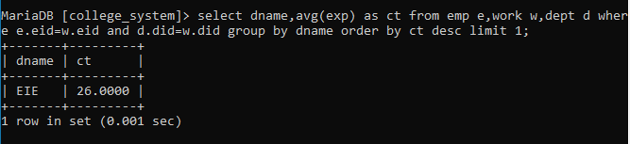

9. Display the name of the employee who designated as “HOD” and who has maximum experience:

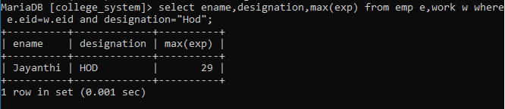

10. Display the name of the employee and department name whose salary is between Rs 40000 and Rs. 60000:

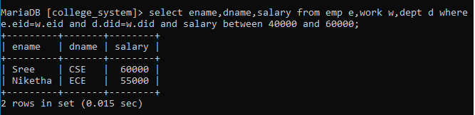

11. Display the average salary of employee whose age is less than 40:

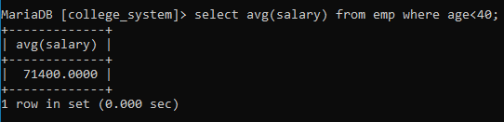

12. Display the name and salary of the employees whose experience is more than 10 years:

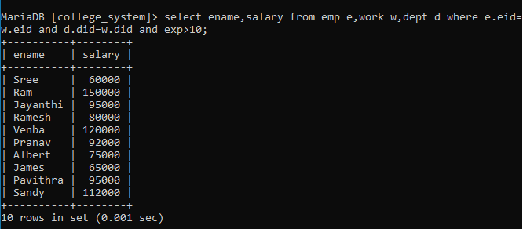

13. Display the employees name who works in CSE and salary is maximum:

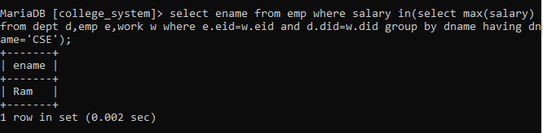

14.Display the name of the employees whose age is greater than 40:

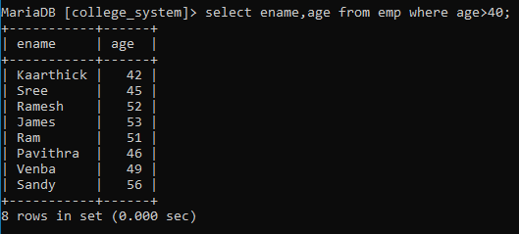

15. Display the department which has the highest number of employees:

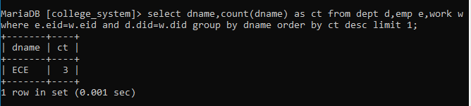

16. Display the name of the staff who are associate professors: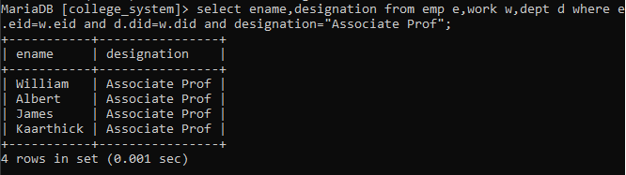

17. Display the name and salary of the employees whose experience is more than 10 years and salary is greater than 60000:

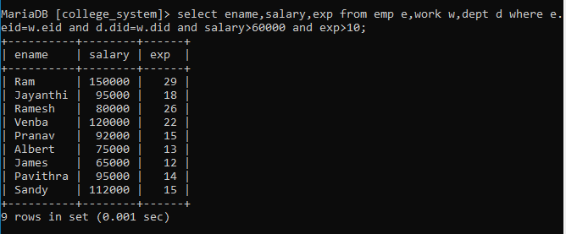

18. Display the total salary incured by every department:

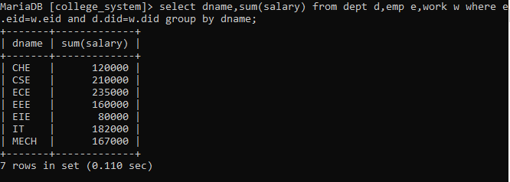

19.Display the employee name where the department name is CSE:

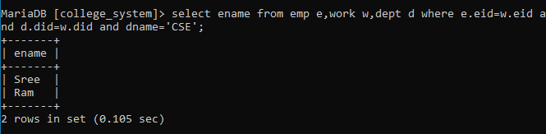

20.Display the count of various employees of different designation:

